MMWA 2018
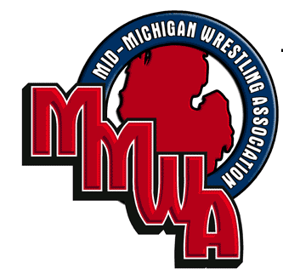
HIGH SCHOOL STATE FINALS
March 11, 2018
Dort Federal Credit Union Event Center
3501 Lapeer Rd
Flint, MI 48503
3501 Lapeer Rd. Flint MI 4FFformerl85033501 Lapeer Rd. Flint MI 4
8503F
Information: Greg Wojciechowski, wojcon@aol.com or 810-358-6158
Email names, school or club and approximate weight to Lauretta Allen
Dlballen64@gmail.com by Wednesday, March 7th.

Eligibility: Open to any High School wrestler that DID NOT qualify for MHSAA Individual State Finals. Limited to first 300 wrestlers!

Entry Fee: $15.00 per wrestler, Cash or Make Check to: MMWA Wrestling paid prior to weigh-in. Wrestler must be USA Wrestling member USA folkstyle card for $15.00 may be purchased online there is a link on mmwawrestling.com .

Admission: $5.00 Adult – 18 years and older
$3.00 Child
Children 3 and Under Free

Weigh-ins: 7:00-8:00 am, Sunday, March 11, 2018
Start Time: 9:30am. Opening Ceremony Start 9am

Awards Ceremony: All during the day, as weight classes are completed.
Rules: HIGH SCHOOL RULES.
Weights: Standard High School weight classes: includes 2 lb weight allowance
105, 114, 121, 127, 132, 137, 142, 147, 154, 162, 173, 191, 217, 285.

Tournament
Rules: 1. Only 2 coaches per match.
2. Coaches lanyard with pass required for anyone to be on the main floor.
2. Any person operating video equipment on the mat will be considered a coach.
3. All wrestlers must leave the wrestling area at the end of their bout.
4. No weight will be challenged after the start of the second round.
5. Proper conduct from wrestlers, parents, and spectators is expected. Penalty for not following tournament rules is expulsion from tournament or forfeit of match.
***Concessions available all day!!***
**No crock-pots or any other electrical cooking devices allowed**
**No Coolers, etc allowed in the Seating Area**

